NJLA Young Adult Section Meeting Minutes
January 17, 2014
South Brunswick Public Library

Members in attendance: Erica Solomon (Piscataway), Katie Llera (Bound Brook High School), Sandi Cronce (Willingboro), Sue Grotyohann (Monroe Twp), Carolyn Aversano (Mercer County- West Windsor), Kathleen Gruver (Burlington County), Saleena Davidson (South Brunswick PL), Sharon Rawlins (NJ State Library), Jen Schureman (GCLS), Megan England (Atlantic City Free PL), Liz Burns (Talking Book & Braile Center), Laura Leonard (Hillsdale), Christen Orbanus (Camden County), Michelle Petrasek (Paterson), Sandy Hall (Morristown & Morris Township), Lynn Mazur (Bridgewater), Karen Mitchell (Highland Park), Kate Vasilik (Piscataway), Karen deWilde (Livingston), Keisha M. Miller (South Orange), Susan Wengler (St. Dominic Academy), Ann-Marie Aymer (Summit), Linda Tripp (Warren/SCLS), Justin Kantonicoutau (Montclair), Megan Pehanick (Ocean County), Amy Behr (North Plainfield), Katie Nellen (Park Ridge H.S.), Rosy Henderson (New Brunswick), Jen Apgar (NJSL, Talking Book & Braile Center), Karen Klapperstuck (Monroe Twp.).

UPDATES FROM AROUND THE STATE
Sent via email

Member Updates: http://njla.pbworks.com/Member-updates

UPCOMING EVENTS

ALA Mid-Winter
- YALSA Happy Hour on Saturday

Diversity and Outreach Section
- First Meeting February 4th, 10am at East Brunswick

Tab Summits
- Registration is live on Feb. 1st
- March 8th: Atlantic City, Princeton, Hassbrook
- March 22nd: Cherry Hill, Bernardsville
- Everyone is asked to bring a snack to ease cost on hosting libraries

YA Literature Symposium
- November in Austin, TX
- Megan England is presenting

ONGOING BUSINESS

YA Section Information Sessions
- Hold info sessions to give an opportunity for other YA librarians in the state to see what we are about
- One session up North: Secaucus has volunteered; Two sessions in South Gloucester County has volunteered to be one location, trying to find second location closer to southern shore. Still working on dates.
- Executive Board along with volunteers from area YA Section Members will answer questions and explain what it is we do as a Section.

YA Section Blog
- Katie L, started a blog for our section
- Currently all posts must be sent to Katie L or Jen to be posted
- Check it out at: http://njya.wordpress.com/
- Blog has been made private
NJLA Conference
- Revel Casino, Atlantic City - June 2, 3, 4th
- Conference Committee will get email of accepted proposals out sometime next week.

TAB Forums
- South: Atlantic City, Cherry Hill
- Central : Princeton
- North: Bernards Twp, Hasburg Heights
- Contact Saleena if you would like to volunteer your space or help out sdavidson@sbpl.info

Executive Board/GSTBA Nominations
- Looking for Nominations for Executive Board positions and GSTBA Committee
GSTBA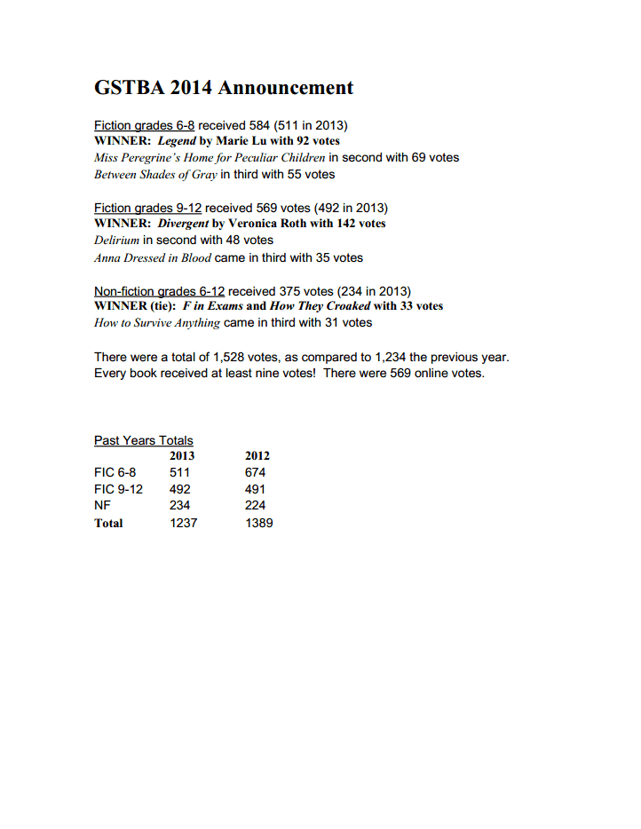

OPEN FORUM
No open forum took place so that we could proceed with the GSTBA Nominations/Selections for Grades 6-8

Titles that made the ballot are as follows:
Wondershow | by Hannah Barnaby

After the Snow | by S.D. Crockett
Vessel | by Sarah Beth Durst

The Last Dragonslayer | by Jasper Fforde
Don't Turn Around | by Michelle Gagnon

Friends with Boys | by Faith Erin Hicks

Keeping the Castle | by Patrice Kindl
See You at Harry's | by Jo Knowles
Enchanted | by Alethea Kontis

The False Prince | by Jennifer Nielsen

Dodger | by Terry Pratchett
Shadow on the Mountain | by Margi Preus

Sons of 613 | by Mike Rubens
After Eli | by Rebecca Rupp

Endangered | Eliot Schrefer

Seraphina | by Rachel Hartman
Reluctant Journal of Henry K Larson | by Susin Nielsen

Drama | by Raina Tele
My Sister Who Lives on the Mantlepiece | by Susin Nielsen

two alternates

No Crystal Stair | by Raina Telgemeier
Obsidian Blade | by Pete Hautman

2013-2014 MEETING SCHEDULE

The section meets six times per year on Fridays at the South Brunswick Public Library: 110 Kingston Lane, Monmouth Junction, NJ.

Jan 17, 2014 – coffee & snacks at 9:00, meeting at 9:30
GSTBA ballot deliberations for FIC 6-8 after business meeting *
Mar 7, 2014 – coffee & snacks at 9:00, meeting at 9:30
GSTBA ballot deliberations for FIC 9-12 after business meeting *
April 11, 2014 – coffee & snacks at 9:00, meeting at 9:30
GSTBA ballot deliberations for Non-fiction 6-12 after business meeting
May 16, 2014 – coffee & snacks at 9:30, meeting at 10:00
Potluck lunch & open house to follow!

* In case of snow, the deliberations will be postponed until the following meeting.
* March and April meetings will be Snow Days – that is, if the March meeting is cancelled, it will be made up on April 11.

The back-up location for our meetings is the HQ Branch of the Burlington County Library: 5 Pioneer Boulevard, Westampton, NJ. Any changes will be announced as soon as possible on the Young Adult Services Section page of the NJLA wiki.

Respectfully submitted by Jen Schureman, Young Adult Services Section Secretary

