NJLA Young Adult Meeting
Friday March 17, 2017
10:00 – 10:15am, coffee & networking,
10:15am – business meeting
Hosting Library: South Brunswick Public Library

Meeting called to order at 10:12am
Introductions
2016-17 Executive Board
Saleena Davidson, President/ Teen Librarian at South Brunswick Public Library
Rosy Wagner, Vice President/Teen Librarian at Burlington County Library System
Jes Schneider, Member-at-Large/ Teen Librarian at East Brunswick Public Library
Keisha M. Miller, Secretary/ Teen Librarian & Volunteer Coordinator at South Orange Public Library
Kristen Churchill, Member-at-large/Teen Librarian at West Orange Public Library
Attendants
- Maureen Langley, YA/Ref Libarian/ Franklin Township Public Library
- Carolyn Aversan, Teen Librarian/Ocean County – Jackson
- Katie Salerno, Teen Librarian/ Somerset County – Bridgewater
- Melissa Brinn, Teen Librarian/Cherry Hill Public Library
- Jamie Dunn, Reference Librarian/Ocean County – Barnegat
- Colleen Affrime, Children’s Librarian/Ocean County – Jackson
- Sue Grotyohann, YA/Ref/Monroe Township Public Library
- Sharon Rawlins, Youth Services Specialist/NJ State Library
- Liz Burns, Reader Services/Talking Book & Braille Center
- Jen Apgar, Youth Services & Reader Services/Talking Book & Braille Center
- Jeff Cupo, Young Adult & Community Services/Montville Public Library
- Danielle Sinai, YA/Camden County Library System – Voorhees
- Sandi Cronce, YA/ Willingboro Public Library
- Emily Mazzoni, YA/Ocean County Library – Toms River
- Maddy Santore, YA/Paterson Public Library Total in attendance: 20
Member Updates
Young Adult Book Fest, April 15, 2017 12:00-3:00pm at Cherry Hill Public (flyer is available under YA News on the NJLA site).
Molly Hone, shared a job announcement for Head of Children’s Services at Pequannock Public Library via email (with Keisha). Complete details can be found at: https://njla.org/content/head-childrens-services-pequannock-township-public-library

Updates from around the state
No updates from Talking Book & Braille Center
Sharon Rawlins shared if anyone is interested in being on the planning committee for the Youth Services Forum for October 2017 – email Sharon at srawlins@njstatelib.org or Jen Schureman (of the Gloucester County Library System) at jschureman@gcls.org

State Library Update:
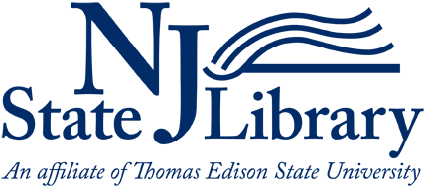
NJSL Report for YA Section Executive Board Meeting, March 17, 2017
Submitted by Sharon Rawlins, Youth Services Specialist for Lifelong Learning, NJ State Library
Seeking Volunteers for the Planning Committee for the annual Youth Services Forum
Have you attended the Youth Services Forum in the past and felt the desire to have more of an impact on the programs offered? The Youth Services Forum, an annual conference for youth services librarians, is looking for volunteers for the Forum’s planning committee (you must be a member of NJLA). You would be working closely with Jennifer Schureman, Project Manager and Sharon Rawlins, Project Consultant, to plan and organize the Forum, sponsored by NJLA, the State Library, and NJASL. This popular annual event, now in its 27th year, is organized and presented by NJLA and NJASL members. The majority of the planning meetings are conducted via teleconference or email but it is essential that you be present at the Forum, usually held in October each year. For more information about this position, please contact Jennifer Schureman, Gloucester County Library System, jschureman@gcls.og, or Sharon Rawlins, Youth Services Specialist, NJ State Library, srawlins@njstatelib.org, 609-278-2640 ext. 116.
Libraries Selected to Host Math and Science Story Time (MASST) Program Series
The NJ State Library and the National Institute for Early Education Research (NIEER) at Rutgers University are collaborating to offer ten public libraries the opportunity to participate in the Math and Science Story Times (MASST) Series: Bringing math and science to life through reading and art for preschoolers in a community-based setting, a STEM initiative that serves the Spanish-speaking community. The public libraries selected to host this series are:
- Elizabeth Public Library
- Fairview Free Public Library
- Palisades Park Public Library
- Summit Free Public Library
- Twin Rivers Branch of the Mercer County Library System
- Union Public Library
- Van Buren Branch of Newark Public Library
- Nilsa Cruz-Perez Branch of Camden County Library System
- North Plainfield Memorial Library of the Somerset County Library System
- Sadie Pope Dowdell Library, South Amboy

They will receive resources kits, training, and be provided with a Spanish-speaking presenter, if needed.
MASST is a story time series focusing on children ages 3-6 and their families in the Spanish-speaking community and includes 8 sessions, each focused on a different area of science or math. Session kits include lesson plans, books, and materials. Sessions involve reading, gross motor activities, singing, and hands-on creative projects that link to the focal topic. Children attend one or more MASST sessions with their family members or caregivers, and related handouts encourage families to extend learning into the home.
2017 Best Practices in Early Literacy Awards
The winning libraries have been selected for the 2017 Best Practices in Early Literacy Awards. They are:
- Camden County Library for its First Visit Kits
- Gloucester County Library – Logan Branch for its Library Children’s Garden
- Sussex County Library for its Read and Play Program

Staff from these winning libraries have been notified and invited to attend the NJLA Conference to accept their checks for $1,000 and certificates of appreciation. Brochures with descriptions of their winning programs will be distributed to attendees at the NJLA Conference in Atlantic City.
2017 CSLP Teen Video Challenge
The NJ summer reading committee has received entries from seven NJ public libraries participating in the 2017 Teen Video Challenge (2017 TVC), a CSLP sponsored national video competition for teens (ages 12 – 18) in public libraries to create videos that promote reading, libraries, and the 2017 CSLP teen summer reading slogan, “Build a Better World.” The judges selected Bordentown Public Library as the winner of the challenge. Each state’s winning video will be promoted nationwide on the CSLP website. The winning teen or teen group will win receive a gift certificate for prizes worth at least $50 from Demco/Upstart for their local public library and all participating teens from the winning library will receive certificates of appreciation. The winners will be officially announced by CSLP in April 2017 during their Annual Meeting. The winning videos will be posted on the CSLP’s website (www.cslpreads.org) in April. It will also be posted on the summer reading page of the State Library’s website.
Statewide Summer Reading Workshops
Registration opened on February 6, 2017, for the statewide summer reading committee workshops to offer public library staff with ideas for their library’s summer reading programs for all ages. The workshops dates are:
- Wayne Public Library on March 6, 2017
- Gloucester County Library in Mullica Hill on March 10, 2017
- Franklin Township Public Library (Somerset County) on March 20, 2017
- Monroe Township Public Library (Middlesex County) on March 27, 2017
Registration and coffee begins at 9:30am and sessions start at 10am. Workshops will end at 1pm. All participants are welcome to bring left over summer reading incentives/prizes from previous summer reading programs to “swap” with each other. Registration information for the workshops can be found on the summer reading website: www.njsummerreading.org.

Library LinkNJ Update:

Incubator Project: Powering Up: Library Charging Stations
We are delighted to announce the launch of the Powering Up: Library Charging Stations initiative.

Powering Up will promote the New Jersey library community’s goals of being safe havens and centers of community support, articulating their value, and supporting library user technology by awarding funds for the purchase of secure public device charging stations for up to 12 of our members.

We hope your interest is piqued. We’ve budgeted $75,000 for this project and look forward to reading your wonderful applications, issuing awards, and later learning about the impact of the project on your libraries. Applications are due by 4:00 pm on Friday, April 28, 2017.

For full details, please visit the Powering Up project page.

Strategic Planning Update

In February & March, we held seven Stakeholder Engagement Workshops across the state, with over 150 library staff from all types of libraries and jobs. The incisive, thoughtful notes and drawings (yes, drawings - your colleagues are multi-talented!) from participants are available on the LLNJ website for you to review.

We are scheduling further events, including an online survey, in-depth interviews with key colleagues across the state and online focus groups for staff in member libraries of all types.

We will share information about each of these opportunities to participate in the Strategic Planning Process as we schedule them, and hope you can join us.

TechFest Materials Available
Colleagues from around the state learned so much at this winter’s two TechFest events, and we’re happy to provide all the handouts from Table Talks on the following topics:

- Online Outreach Tools For Free & Low-Cost Promotion and Marketing
- Podcasts for Professional Development: The Best Apps for Learning
- Augmented Reality: Practical Applications for Libraries
- Lending Non-Traditional Items: What & How
- Web Tools for Teaching Specific Topics & Engagement
- Chromecast Tips & Tricks
- Learning to Code & Computational Thinking
- Mobile Gaming For Community Engagement
- Crowdfunding Library Projects
- Understanding Two-Factor Authentication (2FA): Authentication Issues for Libraries
- Password Managers: An Essential Tool for Digital Security and Privacy
- Virtual Reality
If you missed the event or just want to share a handout with colleagues at your home institution, we’ve got you covered.

Learn At Your Leisure With Webinars
Our most recent webinars make quite a trio for library staff in a wide variety of roles, and as always, we’ve archived the live presentations, along with the presenters’ slides and other related materials.

Get caught up or share a link with a colleague for:
- Fresh Lit 2016, with Roz Reisner. This annual readers’ advisory treat brings you highlights of current and forthcoming titles especially good for book groups.
- Data Visualization for the Rest of Us, presented by Linda Hofschire. You collect all sorts of data at your library; now learn how to present it visually for patrons, board members, administrators and other stakeholders.
- Library Paparazzi: Next-Level Tips for #LibrariesOfInstagram, presented by Claire Schmieder and Sophie Brookover. Tools, tips & tricks for making your library’s Instagram account the best it can be!

Ongoing Business

Young Adult Section Year Ahead (2017-18)
Rosy announced dates and hosting libraries for the upcoming year. Confirmation of dates and hosting libraries will be announced at NJLA 2017. (Made a note to consider holidays, NJ Makers Day 2018 and Teen Toolbox session(s) – one in the north and one in the southern part of the state).
How does everyone feel about a guest speaker for a “soap box” (about 15 minutes) at the beginning of YA meetings September – December, 2017? (soap box feature would be a guest from, i.e. Talking Book & Braille Center); unanimous vote.
Could the meeting in Maplewood be the Teen Toolbox and then another (in the spring – possibly April, 2018)?
Rosy will send out a survey which will include the above ideas by the end of the day (3/17/17).

For NJLA Conference this year:
Call for Volunteer Photographers: anyone interested in volunteering to be a photographer, email Keisha, kmiller@sopl.org . Need approximately 2-3 photographers. Please let me know by Monday April 10. Details will follow.
Liz Burns will bring some stuff to put on the table at conference. Also Sue will bring some flyers as well. Anyone is welcome to bring flyers, and leave at the table as well. You can email Saleena in a pdf form by April 15, 2017. Hashtag to use: #yassnjla (this is also the handle on Instagram for the YA section - @yassnjla).
Tuesday April 25, 2017 is the Brown Bag Lunch with CSS, all are welcome to attend. Learn about what each section (YA & CSS) does and have a chance to talk to officers.

Garden State Teen Book Award Deliberations, Nonfiction 9th-12th grade ballot
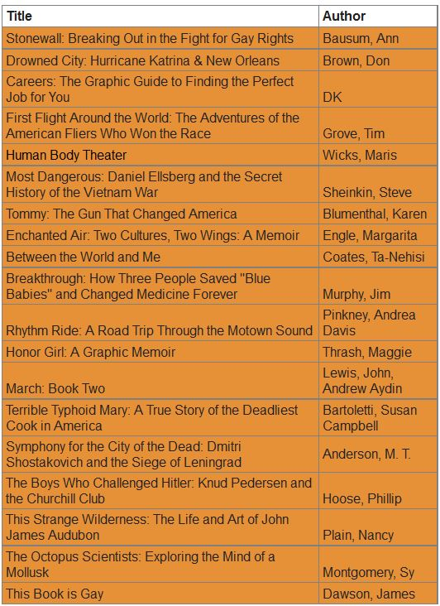
Meeting adjourned at 10:48am. Break for 10 minutes before GSTBA deliberations.
Deliberations concluded at 12:18pm.

